23.48:
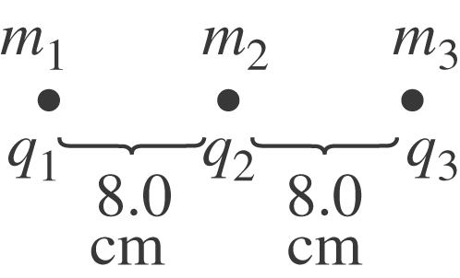

(a) 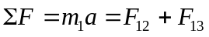
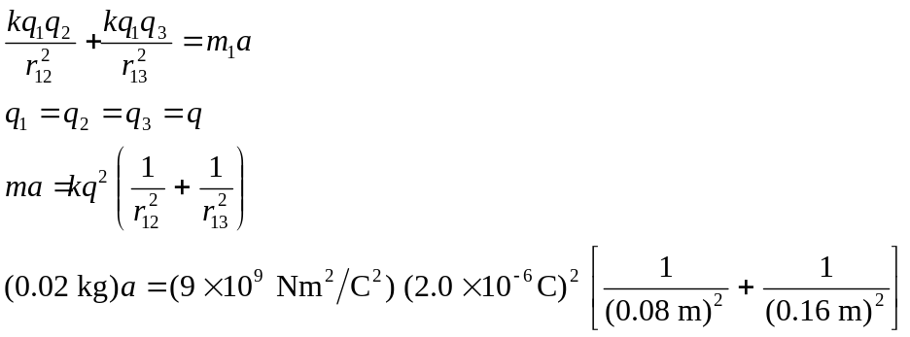
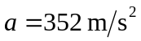

(b) Maximum speed occurs at “infinity”. The center charge does not move since the forces on it balance. Energy conservation gives 